1.
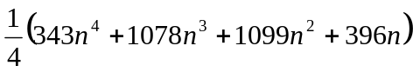

2.
Prove by mathematical induction.

3.

4.
Asymptotes : 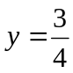 , 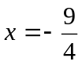
Axial intercepts : 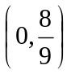 , 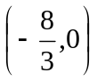
The function is decreasing.

